Muhammad Luqman

G00353385

Design Document

Space Of War



**Table of Contents**

**Overview** 2

**Objectives** 2

**Scope of Game** 2

**Features** 3

**System Requirements** 3

**Developing Tools and Programming Languages** 3

**Front End** 4

**Splash Screen** 4

**Main Menu** 5

**Options** 6

**High Scores** 7

**In-Game Menus** 8

**Control Mechanisms** 8

**The Game** 9

**Game Dynamics** 9

**References** 10

# **Overview**

This is a 2d to be developed as part of the Mobile Applications Development module requirements. This is a shooter game in classic top-down, vertical scroller format. I researched various games and then decided to have a go and create this game because I played a bit similar game known as chicken invaders as a kid. I was always fascinated by the idea of becoming a game developer, but, as years went by, I have realized this is not exactly what programming and computer science, as a practice, are about and I dropped the idea. However, the third-year project offered me the possibility to try and achieve one of my childhood’s dreams.

# **Objectives**

The game is developed for full-time entertainment and enthusiasms. It teaches the Gamer to be alert at every situation.

Though the proposed game is an action game, it doesn’t involve direct violence. No zombie killing, animal killing, or human killing is performed in the game. So, it can also be viewed as a nonviolence game.

Kids can also play this game, because the design of the game is very simple, controlling the game is very easy – pressing some neighboring keys of the keyboard.

# **Scope of Game**

This Report describes all the requirements for the project. The purpose of this research is to provide a virtual image for the combination of both structured and unstructured information of my project “Space of War”. This is a single-player strategy game on the Windows platform. The player will progress through levels which require manipulation of the environment, though the game. I demonstrate the action flow between inputs, script, display (output). We are working mainly with levels (for now 3 levels max), object, animation, graphics, scripts, game engine facilities.

# **Features**

* Attractive Background
* Spaceship(player)
* Enemy Types (Enemy ships, asteroids and boss enemy)
* Live Score
* Lives Display
* Background Music
* Sound Effects (shooting, destroying, etc.)
* Startup Menu
* Pause Menu

# **System Requirements**

Most of the computer games require high configurations of computer. But in the case of the proposed gaming system, the system requirements are not that much.

The systems requirements for the proposed project “Space of War” game is mentioned following.

* Operating System: Windows XP, 7, 8, 8.1, 10
* RAM: 1 GB
* Processor: Pentium, Pentium iv or onwards
* Hard Disk: 100 MB

# **Developing Tools and Programming Languages**

* Unity
* Visual Studio
* C#

# **Front End**

My front end of the game user interface consists of the following components

* Splash Screen
* Main Menu
* Options Menu
* High Scores Table

## **Splash Screen**

The splash Screen will be shown to the user for few seconds when the game run. The design of the splash screen that I made for my game is below



## **Main Menu**

After the Splash screen user will be taken to the main menu which will contain 3 buttons.

* Play
* Options
* Quit

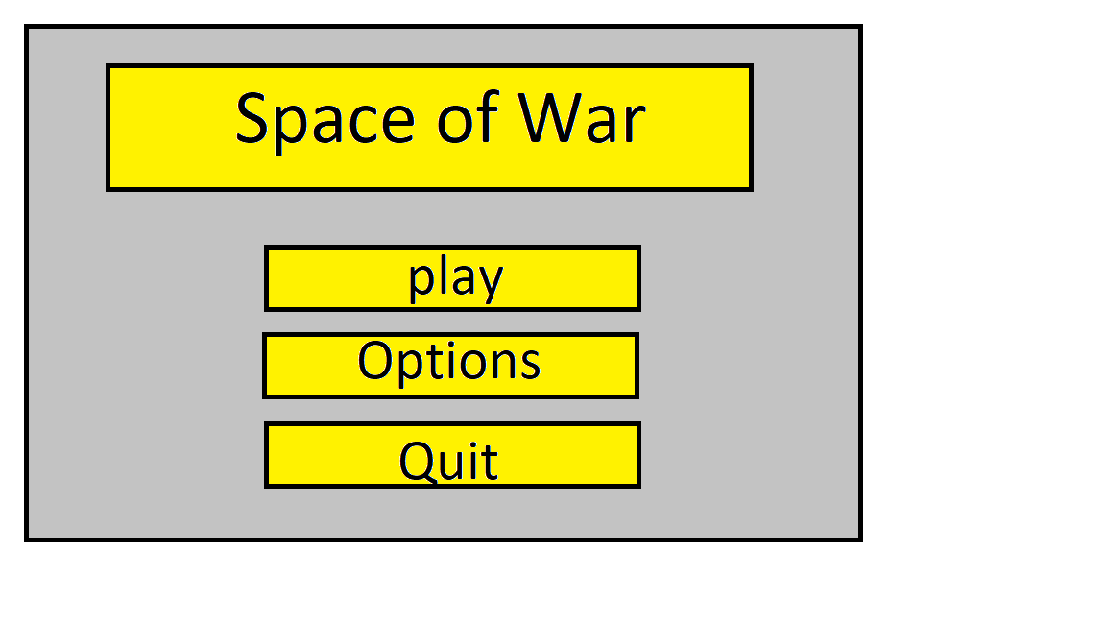

**Play**

When user selects play button then game play user interface displays and the game starts.

**Quit**

When user clicks on quit button it exits the game.

## **Options**

When user selects the options button then it takes the user to options menu screen where there are three options for the user to select from which are as follows

* Music Adjustment
* Sound Adjustment
* High Scores

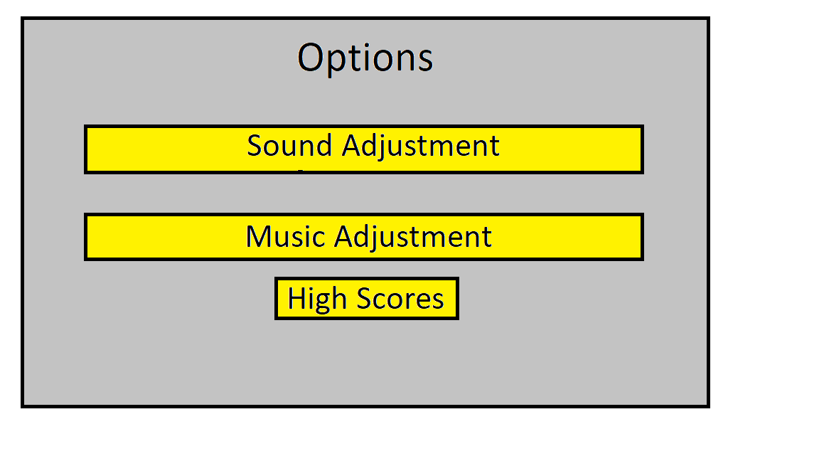

**Music Adjustment**

There will be a slider for the user to adjust the level of the music volume in the game.

**Sound Adjustment**

There will be a slider for the user to adjust the level of the sound effects volume of the game.

## **High Scores**

If the user clicks on High Scores button, then a High Scores table will be shown on the screen which displays high scores record.

It contains 3 fields and it will only show top 3.

* **Rank** which compares the scores of all the users who played this game and then shows theirs rank based on the comparison.
* **Name** which displays the name of the user associated with the player.
* **Scores** which displays the scores of the players.

Example Design is as follows

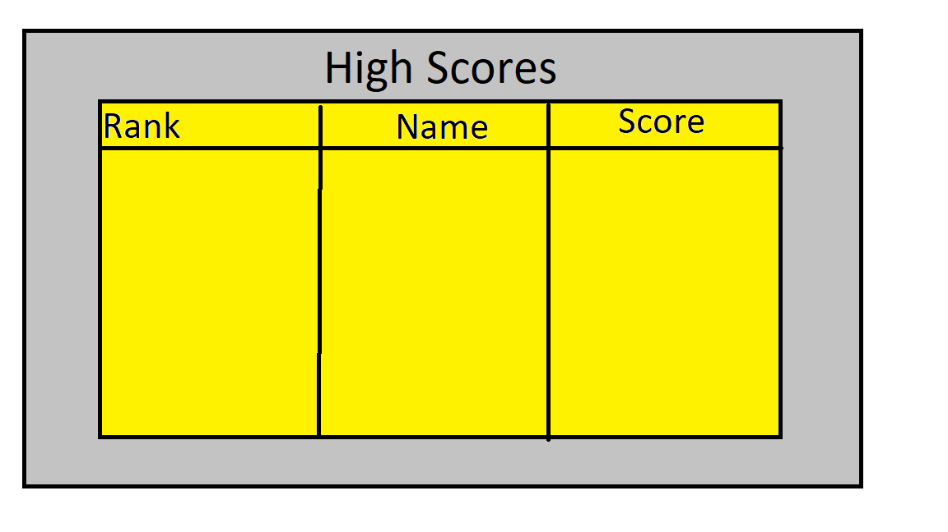

# **In-Game Menus**

My game consists of the following in game menus

* **Options Menu** which is same as the one described above and will be shown when the user pauses the game by pressing Esc button while game play.
* **Name Form** which appears when game over and will ask for player name and will save the player names in the High Scores table in association with its score.

# **Control Mechanisms**

The control mechanism of this game is very simple and similar to most games.

**Movement** of player works with arrow keys such as to move the player left press left arrow key, to right press right arrow key, to move up press up arrow key and to move down press the down arrow key.

To **shoot** bullet press spacebar key.1 press fire bullet 1 time.

# **The Game**

The game play screen contains score tab which displays the live score during gameplay, Lives tab which displays the player lives left during gameplay, a player ship, enemies and vertically scrolling background.

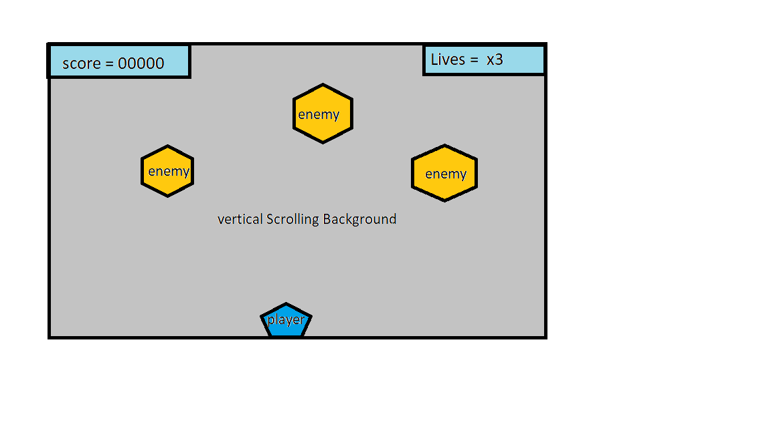

## **Game Dynamics**

The game will have 3 levels it will start from easy level when enemies will have more delay in spawning and user will have to get the required score by destroying the enemy ships. I haven’t decided the required score yet.

When player achieves the required score then game proceeds to level 2 and become difficult. Enemy ships spawning becomes fast means the delay between spawning enemies decreases and with enemy ships asteroids will also spawn and user will have to either avoid them or destroy them.

After achieving the required score in level 2 by player then the game will proceed to level 3.

This is a Boss fight level there will be power ups spawning randomly and user will have to defeat the boss by shooting it.

# **References**

<https://www.interactionstudios.com/chickeninvaders.php>

<https://www.bunchball.com/gamification/game-mechanics>

<https://www.giantbomb.com/chicken-invaders/3030-12744/similar-games/>

<https://docs.unity3d.com/Manual/class-PlayerSettingsSplashScreen.html>

<https://www.instructables.com/id/How-to-make-a-main-menu-in-Unity/>